**FINAL PROJECT WORK – RASHAD SURVEY DATA ANALYSIS**

|  |  |  |  |
| --- | --- | --- | --- |
| **Statistics** | | | |
|  | | Age | Environmental Concern |
| N | Valid | 31 | 31 |
| Missing | 0 | 0 |

Apparently, the dataset includes 31 valid observations for the both ages and environmental concern, with no missing values (N missing = 0). However, this has complete the dataset which ensures reliability for further analysis while allowing comprehensive exploration between age and environmental concerns.

|  |  |  |  |  |  |
| --- | --- | --- | --- | --- | --- |
| **Age** | | | | | |
|  | | Frequency | Percent | Valid Percent | Cumulative Percent |
| Valid | 18-25 Years | 2 | 6.5 | 6.5 | 6.5 |
| 26-35 Years | 25 | 80.6 | 80.6 | 87.1 |
| 36-45 Years | 3 | 9.7 | 9.7 | 96.8 |
| 46-Above Years | 1 | 3.2 | 3.2 | 100.0 |
| Total | 31 | 100.0 | 100.0 |  |

Therefore, the dataset provides the age distribution of 31 respondents across four age group:

* **18-25 Years:** Represent 2 individuals accounting for 6.5% of the total
* **26-35 Years:** Represent the largest group with 25 individuals, making up to 80.6% of respondents.
* **36-45 Years:** Represent 3 individuals, accounting to 9.7%
* **46 Years and Above**: Represent 1 individual, or 3.2%

Ultimately, the survey results may be impacted by the high concentration of young adult responses, as the majority of the respondents (80.6%) are between the ages of 26 and 35.

|  |  |  |  |  |  |
| --- | --- | --- | --- | --- | --- |
| **Environmental Concern** | | | | | |
|  | | Frequency | Percent | Valid Percent | Cumulative Percent |
| Valid | Agree | 21 | 67.7 | 67.7 | 67.7 |
| Neutral | 2 | 6.5 | 6.5 | 74.2 |
| Strongly | 8 | 25.8 | 25.8 | 100.0 |
| Total | 31 | 100.0 | 100.0 |  |

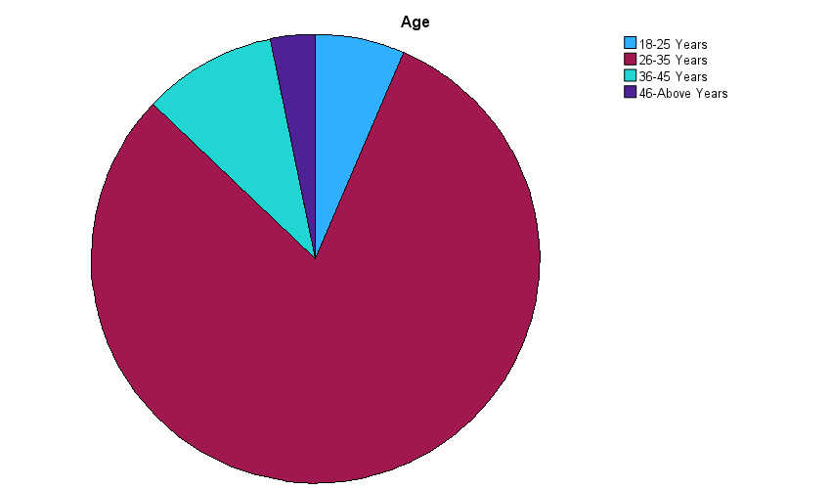

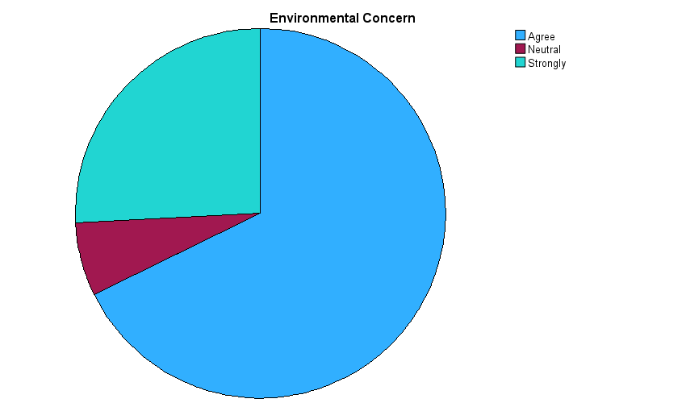

The data on the environmental concerns reflects the responses of 31 participants, grouped into three level of agreement:

* **Agree:** The majority, 21 respondents (67.7%) showed their agreement regarding the environmental concern, indicating the significant level of awareness.
* **Neutral:** Only 2 respondents (6.2%), showing minimal ambivalence within the group.
* **Strongly Agree:** 8 respondents (25.8%) who strongly agreed

Thus, the cumulative percentage reaches 100%, confirming 31 responses are valid. The distribution emphasizes a dominant agreement on environmental issues, with over 90% of respondents showing varying degree of concern.

|  |  |  |  |  |  |
| --- | --- | --- | --- | --- | --- |
| **Age** | | | | | |
|  | | Frequency | Percent | Valid Percent | Cumulative Percent |
| Valid | 18-25 Years | 2 | 6.5 | 6.5 | 6.5 |
| 26-35 Years | 25 | 80.6 | 80.6 | 87.1 |
| 36-45 Years | 3 | 9.7 | 9.7 | 96.8 |
| 46-Above Years | 1 | 3.2 | 3.2 | 100.0 |
| Total | 31 | 100.0 | 100.0 |  |

|  |  |  |  |  |  |
| --- | --- | --- | --- | --- | --- |
| **Purchase Intention** | | | | | |
|  | | Frequency | Percent | Valid Percent | Cumulative Percent |
| Valid | Agree | 19 | 61.3 | 61.3 | 61.3 |
| Disagree | 1 | 3.2 | 3.2 | 64.5 |
| Neutral | 1 | 3.2 | 3.2 | 67.7 |
| Strongly | 10 | 32.3 | 32.3 | 100.0 |
| Total | 31 | 100.0 | 100.0 |  |

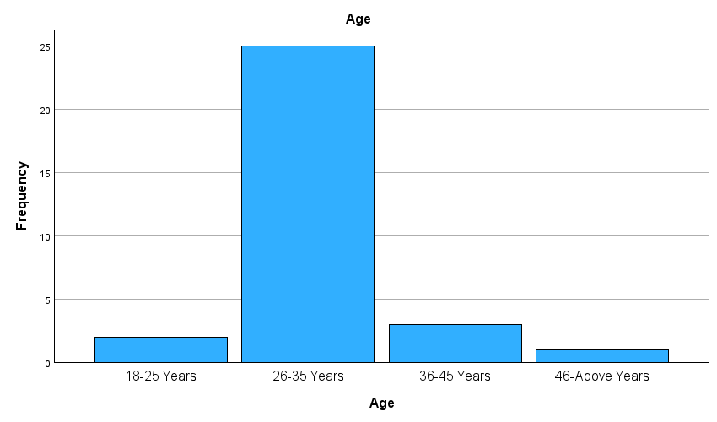

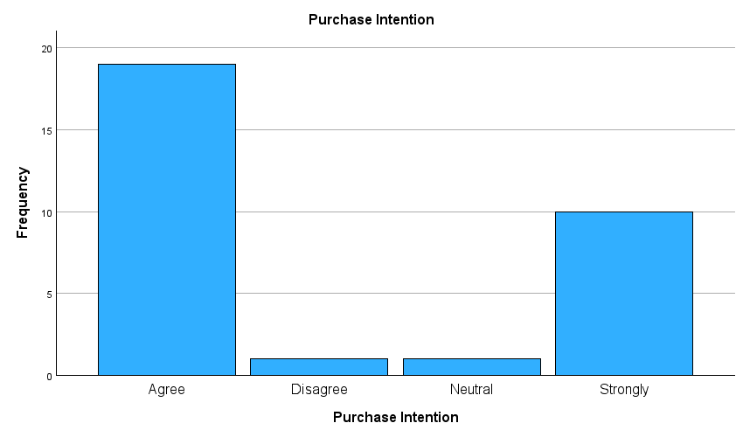

Regarding purchase intention:

* **61.3%** (19 respondents) agree with the positive purchase intention.
* **32.3%(**10 respondents) strongly agree.
* **A small number** disagreed (3.2%) or remain neutral (3.2%)

The combined majority of 93.6%(61.3% agreed + 32.3% strongly agreed) indicates that the respondents’ intention of purchasing is overwhelmingly positive.

|  |  |  |  |  |  |
| --- | --- | --- | --- | --- | --- |
| **Sex** | | | | | |
|  | | Frequency | Percent | Valid Percent | Cumulative Percent |
| Valid | Female | 11 | 35.5 | 35.5 | 35.5 |
| Male | 20 | 64.5 | 64.5 | 100.0 |
| Total | 31 | 100.0 | 100.0 |  |

|  |  |  |  |  |  |
| --- | --- | --- | --- | --- | --- |
| **Environmental Concern** | | | | | |
|  | | Frequency | Percent | Valid Percent | Cumulative Percent |
| Valid | Agree | 21 | 67.7 | 67.7 | 67.7 |
| Neutral | 2 | 6.5 | 6.5 | 74.2 |
| Strongly | 8 | 25.8 | 25.8 | 100.0 |
| Total | 31 | 100.0 | 100.0 |  |

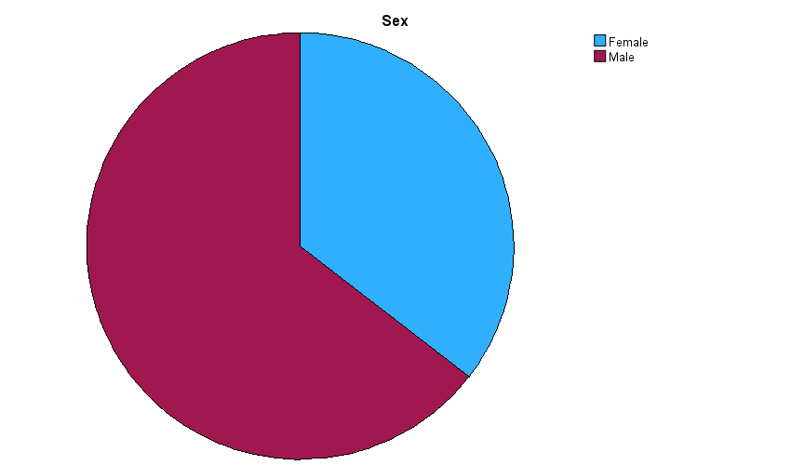



31 individuals answered about environmental concern are included in the dataset. The responses are distributed as follows;

* **Agree:** the majority of the respondents (67.7%) showed their agreement with the environmental concern.
* **Neutral:** a small number ((6.5%) were neutral, indicting neither agree nor disagree.
* **Strongly agree:** 25.8% of the respondents strongly agreed, indicating a strong overall concern for environmental issues among the participants

|  |  |  |  |  |  |
| --- | --- | --- | --- | --- | --- |
| **Sex** | | | | | |
|  | | Frequency | Percent | Valid Percent | Cumulative Percent |
| Valid | Female | 11 | 35.5 | 35.5 | 35.5 |
| Male | 20 | 64.5 | 64.5 | 100.0 |
| Total | 31 | 100.0 | 100.0 |  |

|  |  |  |  |  |  |
| --- | --- | --- | --- | --- | --- |
| **Purchase Intention** | | | | | |
|  | | Frequency | Percent | Valid Percent | Cumulative Percent |
| Valid | Agree | 19 | 61.3 | 61.3 | 61.3 |
| Disagree | 1 | 3.2 | 3.2 | 64.5 |
| Neutral | 1 | 3.2 | 3.2 | 67.7 |
| Strongly | 10 | 32.3 | 32.3 | 100.0 |
| Total | 31 | 100.0 | 100.0 |  |

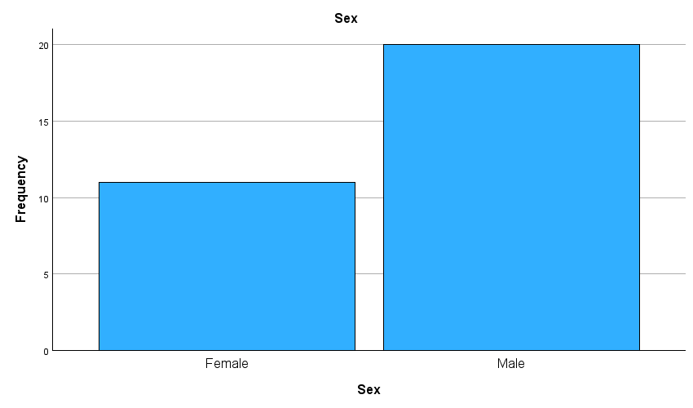



The data on the purchase intention shows the respondents’ attitudes towards a potential purchase.

* **Agreed** has the highest response rate, with 19 participants accounting for (61.3%), showing the majority inclination towards purchase.
* **Strongly agreed** followed, which has 10 participants accounting for (32.3%), highlighting a strong intent among a significant portion.
* **Neutral or Disagreed** having a minimal representation, with only one participant (3.2%) suggesting low level or opposition.

|  |  |  |  |  |  |
| --- | --- | --- | --- | --- | --- |
| **Level of Education** | | | | | |
|  | | Frequency | Percent | Valid Percent | Cumulative Percent |
| Valid | Elementary school Complete | 1 | 3.2 | 3.2 | 3.2 |
| Graduate education complete (Master's Degree, PhD. Doctorate) | 3 | 9.7 | 9.7 | 12.9 |
| High school Complete | 4 | 12.9 | 12.9 | 25.8 |
| Higher education Complete | 7 | 22.6 | 22.6 | 48.4 |
| Higher education Incomplete | 16 | 51.6 | 51.6 | 100.0 |
| Total | 31 | 100.0 | 100.0 |  |

|  |  |  |  |  |  |
| --- | --- | --- | --- | --- | --- |
| **Environmental Concern** | | | | | |
|  | | Frequency | Percent | Valid Percent | Cumulative Percent |
| Valid | Agree | 21 | 67.7 | 67.7 | 67.7 |
| Neutral | 2 | 6.5 | 6.5 | 74.2 |
| Strongly | 8 | 25.8 | 25.8 | 100.0 |
| Total | 31 | 100.0 | 100.0 |  |

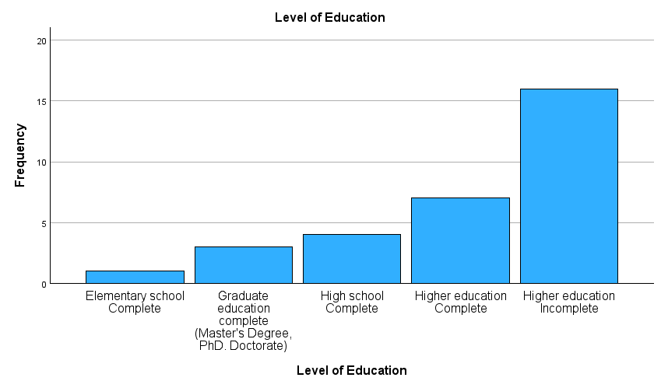

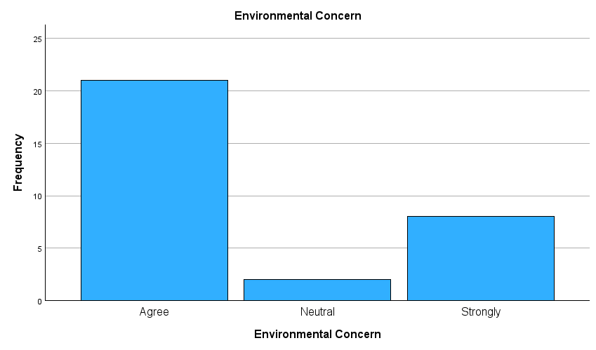

The dataset includes 31 participants’ answers about environmental concern, distributed as follows;

* **Agreed:** 21 respondents (67.7%) showed their agreement, which is the majority.
* **Neutral:** 2 respondents (6.5%) show neutral, contributing to minimally to total.
* **Strongly agreed:** 8 respondents (25.8%) support the environmental concern.

|  |  |  |  |  |  |
| --- | --- | --- | --- | --- | --- |
| **Level of Education** | | | | | |
|  | | Frequency | Percent | Valid Percent | Cumulative Percent |
| Valid | Elementary school Complete | 1 | 3.2 | 3.2 | 3.2 |
| Graduate education complete (Master's Degree, PhD. Doctorate) | 3 | 9.7 | 9.7 | 12.9 |
| High school Complete | 4 | 12.9 | 12.9 | 25.8 |
| Higher education Complete | 7 | 22.6 | 22.6 | 48.4 |
| Higher education Incomplete | 16 | 51.6 | 51.6 | 100.0 |
| Total | 31 | 100.0 | 100.0 |  |

|  |  |  |  |  |  |
| --- | --- | --- | --- | --- | --- |
| **Purchase Intention** | | | | | |
|  | | Frequency | Percent | Valid Percent | Cumulative Percent |
| Valid | Agree | 19 | 61.3 | 61.3 | 61.3 |
| Disagree | 1 | 3.2 | 3.2 | 64.5 |
| Neutral | 1 | 3.2 | 3.2 | 67.7 |
| Strongly | 10 | 32.3 | 32.3 | 100.0 |
| Total | 31 | 100.0 | 100.0 |  |

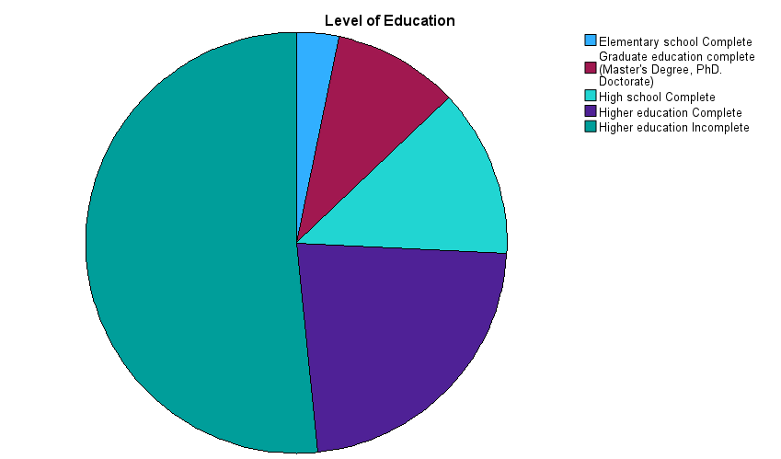

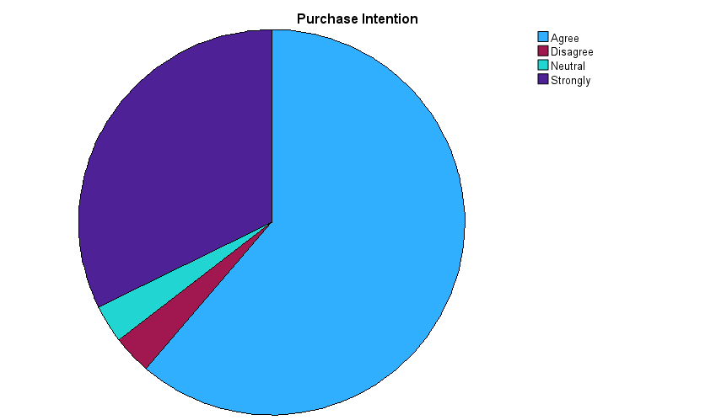

* **61.3%** (19 respondents) agreed with the purchase intention
* **32.3%** (10 respondents) strongly agreed, indicating a higher level of intent
* **A small portion** of respondents were either neutral (3.2%, 1 respondent) or disagree (3.2, 1 respondent).

With 93.2% of respondents strongly agreeing with the purchase intention, the poll results demonstrate a higher level of consumer interest in the topic.

|  |  |  |  |  |  |
| --- | --- | --- | --- | --- | --- |
| **Income level** | | | | | |
|  | | Frequency | Percent | Valid Percent | Cumulative Percent |
| Valid | 10,001-20,000 | 11 | 35.5 | 35.5 | 35.5 |
| 20,001-30,000 | 12 | 38.7 | 38.7 | 74.2 |
| 30,001- Above | 1 | 3.2 | 3.2 | 77.4 |
| 5000-10,000 | 7 | 22.6 | 22.6 | 100.0 |
| Total | 31 | 100.0 | 100.0 |  |

|  |  |  |  |  |  |
| --- | --- | --- | --- | --- | --- |
| **Environmental Concern** | | | | | |
|  | | Frequency | Percent | Valid Percent | Cumulative Percent |
| Valid | Agree | 21 | 67.7 | 67.7 | 67.7 |
| Neutral | 2 | 6.5 | 6.5 | 74.2 |
| Strongly | 8 | 25.8 | 25.8 | 100.0 |
| Total | 31 | 100.0 | 100.0 |  |

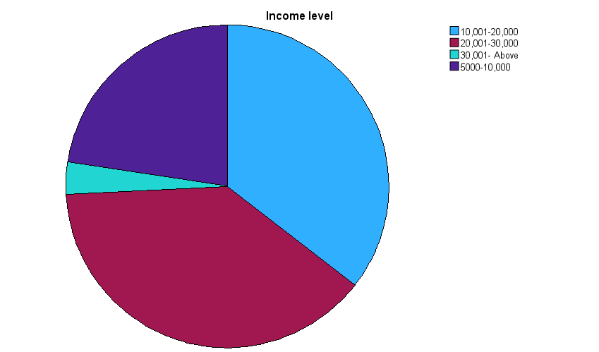

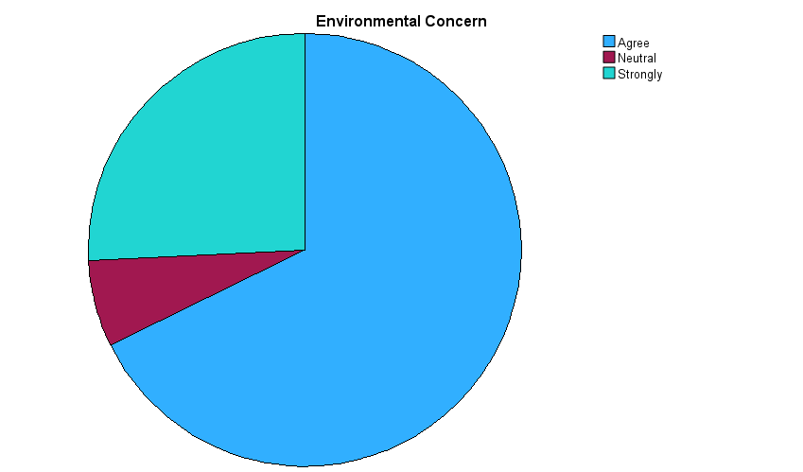

The data on the environmental concerns reveals the following distribution among the 31 respondents;

* **Agreed:** the majority, 21 (67,7%) expressed their agreement on the environmental concern.
* **Neutral**: only 2 respondents (6.5%), remains neutral, neither agreeing nor disagreeing.
* **Strongly agree:** 8 respondents (25.8%) strongly agreed, indicating a high level of concern.

|  |  |  |  |  |  |
| --- | --- | --- | --- | --- | --- |
| **Income level** | | | | | |
|  | | Frequency | Percent | Valid Percent | Cumulative Percent |
| Valid | 10,001-20,000 | 11 | 35.5 | 35.5 | 35.5 |
| 20,001-30,000 | 12 | 38.7 | 38.7 | 74.2 |
| 30,001- Above | 1 | 3.2 | 3.2 | 77.4 |
| 5000-10,000 | 7 | 22.6 | 22.6 | 100.0 |
| Total | 31 | 100.0 | 100.0 |  |

|  |  |  |  |  |  |
| --- | --- | --- | --- | --- | --- |
| **Purchase Intention** | | | | | |
|  | | Frequency | Percent | Valid Percent | Cumulative Percent |
| Valid | Agree | 19 | 61.3 | 61.3 | 61.3 |
| Disagree | 1 | 3.2 | 3.2 | 64.5 |
| Neutral | 1 | 3.2 | 3.2 | 67.7 |
| Strongly | 10 | 32.3 | 32.3 | 100.0 |
| Total | 31 | 100.0 | 100.0 |  |

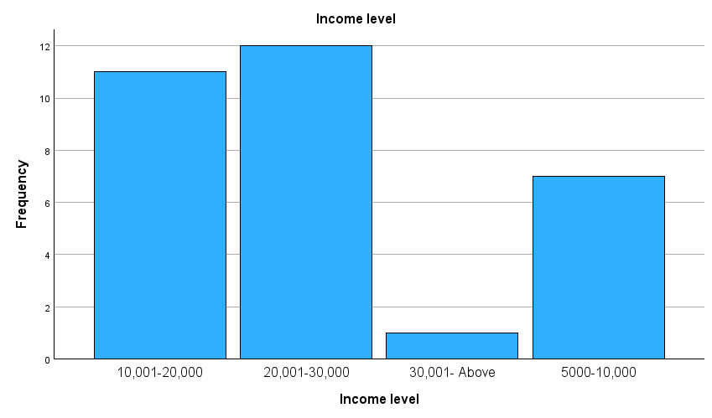

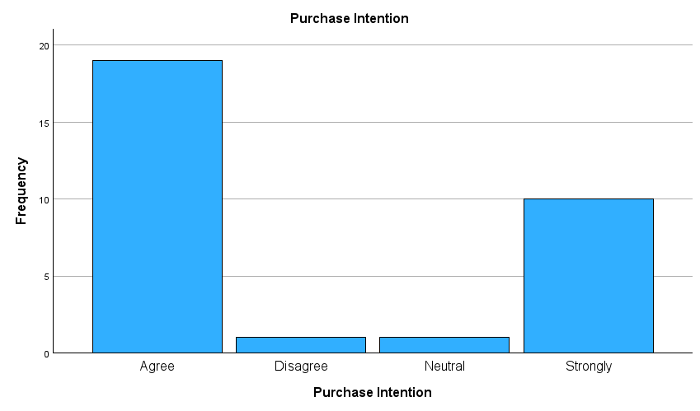

The dataset summarizes responses on purchase intention, collected from 31 participants. The distribution is as follows;

* **Agree:** the majority, 19 respondents (61.3%), show agreement with the purchase intention.
* **Disagree:** only 1 respondent (3.2%) disagreed
* **Neutral:** also, 1 respondent (3.2%) neither agree nor disagree
* **Strongly agree:** 10 respondents (32.3%) strongly agreed

The majority of respondents (93.6%) expressed a strong positive intention towards purchase, with only a small number expressing disagreement or neutrality.